This template is designed to help you to prepare your information before uploading your walk onto www.walkingmaps.com.au. It is most useful for:
- Longer walks or walks that contain detailed information, or
- Walks that require content to be approved (eg. by your manager, communications team) before uploading onto the website.
** For walks that are relatively short and simple, please feel free to go straight to the website and start mapping your walk there **

1. CREATE ROUTE
Name of walk
Level | Choose - Very easy, easy, moderate, challenging, very challenging
Summary (max 200 characters) | Describe walk highlights here
Description (max 3000 characters) | Use this section to give detailed directions if needed, or describe overall background, history or features of the walk.
Hyperlink | Insert hyperlink if relevant.
Mark your walking route | 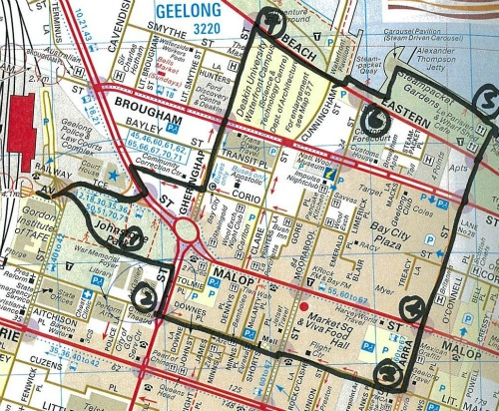  - Using GPS App to track your route  Download ‘Minimalist GPS Tracker’ App. You have to pay $6 to be able to export GPX files.  OR  - Manually mark your route as you walk  - Sketch a map, marking street names, facilities and amenities (toilets, picnic spot etc).  - Mark your route clearly.  - Mark the location of each Point of Interest with a corresponding number.

 | Title | Photo | Description (max 200 characters) & hyperlink if necessary
1 | Historic tree | POI 1 | Mayor John Smith planted this acacia tree in 1925 to commemorate a disastrous flood.  www.smithcouncil.vic.gov.au/acaciawalk
2 |  | POI 2
3 |  | POI 3
4 |  | POI 4
5 |  | POI 5
6 |  | POI 6
7 |  | POI 7
8 |  | POI 8
9 |  | POI 9
10 |  | POI 10

3. WALK DETAILS AND PHOTOS
WALK TYPE & FEATURES | TICK |  | TICK
Historical interest |  | Public transport access
Local treasures |  | Public toilets
Art and culture |  | Playground
Nature trail |  | Picnic spot
Coast / River / Lake |  | Pram friendly
Parks / Gardens |  | Wheelchair friendly
General |  | Drinking water available
Dog off-leash |  | Seating available

